Contents

Taubate OnBase Data Book process overview 2

General Process Overview 2

Top 5 issues 2

Current OnBase System Review - AS-IS High Level Process Overview 3

ITP File 4

Traceability Map – OnBase correspondence 4

Custom Query - SN: 112696396-01 query results (ANM-H CONECTOR 18-3/4" 3 HUB'S BCSS 2000 M) 5

Issue #1 Proposed Solution - OnBase Data Download Program 6

OnBase Data Download Proposed Results 6

Proposed Folder Structure 7

Data processing log file 7

Issue #2 Proposed Solution - Configuration – mapping to keywords 8

Query documents for project 9

Issue #3 Proposed Solution - Notes for Rejection Report 10

Notes for Rejection Report Template 10

Issue #4 Proposed Solution - OnBase DIP from FTP 11

Issue #5 Proposed Solution - Downgrade approval level 12

Quotation – Matricia (Items 1+2+3) 12

# Taubate OnBase Data Book process overview

## General Process Overview

OnBase system is used in Taubate for quality document management system. A number of predefined documents are uses to capture supplier and manufacturer data.

Kofax is used to import document data and extract indexing information in keywords and E-forms are used for customer approvals.

A custom query is used to select all documents specific to 4104 plant.

Different methods and platforms are used during the data book creation process (Excel, Kofax, Onvase and Email communication).

## Top 5 issues

Discussed with Quality management team and identified top 5 claimed issues.

1. **Manual Extraction of Documents**
   * Each OnBase documents is manually downloaded for further processing (data book). This is a time consuming process with several people working on it.
   * Data Book assembly is not considered on this phase. There can be huge improvements on removing the excel spreadsheets and use product templates for data book creation.
2. **Link to Tree#**
   * This is a need to link all documents to a specific project.
3. **Notes for Rejections**
   * No report or method available to automatically track the customer approval and Cameron reaction time to rejections. This adds additional time for data book.
4. **Importing files from FTP**
   * Currently all vendors were instructed to send their certificates through FTP (a 3rd patty is used). Once goods are received for inspection vendor documents are printed and GR_Slip attached printed and scanned through Kofax. The request is to interface current system with OnBase in order to avoid printing, scanning and Kofax indexing.
5. **Downgraded approval level**
   * Once a *folder* has been approved, any other addition or document change to remove the approved status and restart the e-form for customer approval.

## Current OnBase System Review - AS-IS High Level Process Overview

Below is the high level map of the current process showing different methods and platform used.

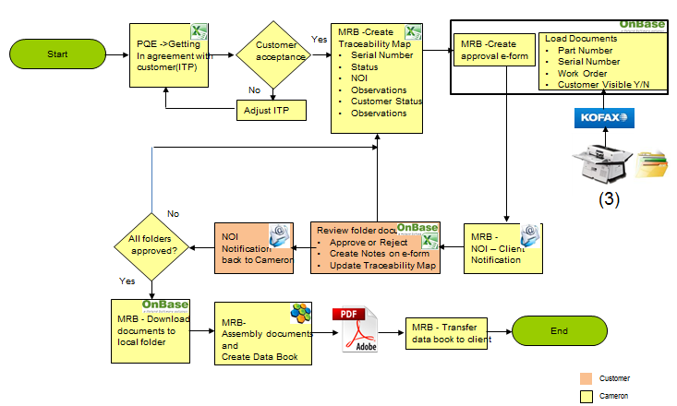

* PEQ – Project Quality Engineers are initiating the ITP file using BOM explosion and get the customer agreement regarding documentation required and holding points for the project. This communication is done through a shared excel file.
* MRB team uses the ITP file to create the Traceability Map file (adding a number of columns to keep tracebility). This will be the shared file used in communication with customer once a serial number has been added and all documents are available for review in OnBase.
* Once all documents are readyfora specific serial number an e-form is released in OnBase for customer approval.
* In addition to this form a list (excel) with serial numbers is sent to customer.
* Customer review the list and run the OnBase custom query for each serial number. Depending on findings he can apporove all documents or reject asking for additional documents or details.
* Once all documents for tracebility map serial numbers have been approved these are manually (one by one) downloaded to a local folder.
* Next step is to assembly all these documnets (Nuance) and create data book. As a rule, data book copy the product structure approved by PQE and customer at the initian phase with some additional cover sheets for each level items.

## ITP File

2 lines for each BOM part number. One with Cameron details specifying MS, QP, PSL and all the required certificates. Customer reviews the proposal and change / add additional requirements.

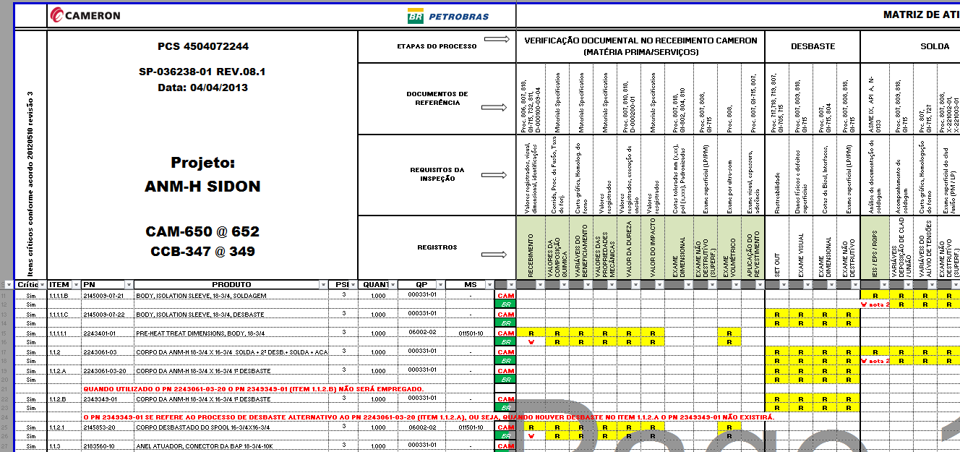

## Traceability Map – OnBase correspondence

MRB team change the layout and keep only the lines containg customer requirements. This file is shared with customer to get details about serial numbers used and execution process status (Cameron and customer)

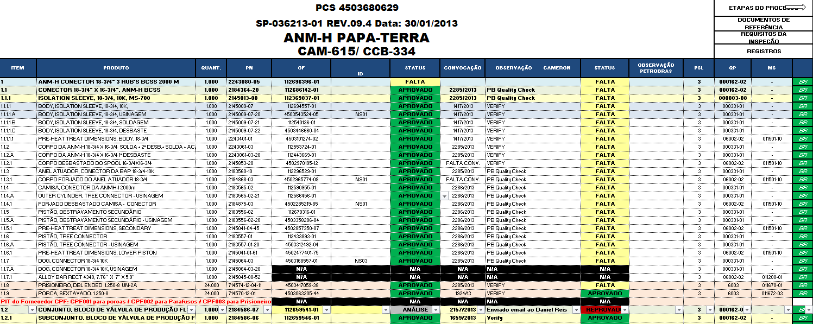

When documents are ready e-form is released for documents approval and customer is notified by email (NOI form). A list with available serial numbers is attached for review.

Sample NOI:

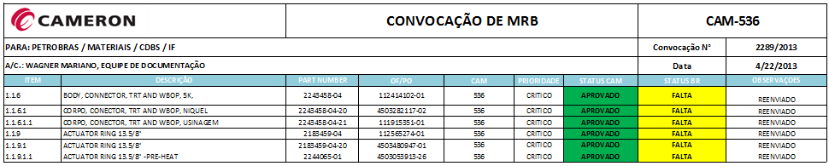

## Custom Query - SN: 112696396-01 query results (ANM-H CONECTOR 18-3/4" 3 HUB'S BCSS 2000 M)

Below is a query result for one specific serial number:

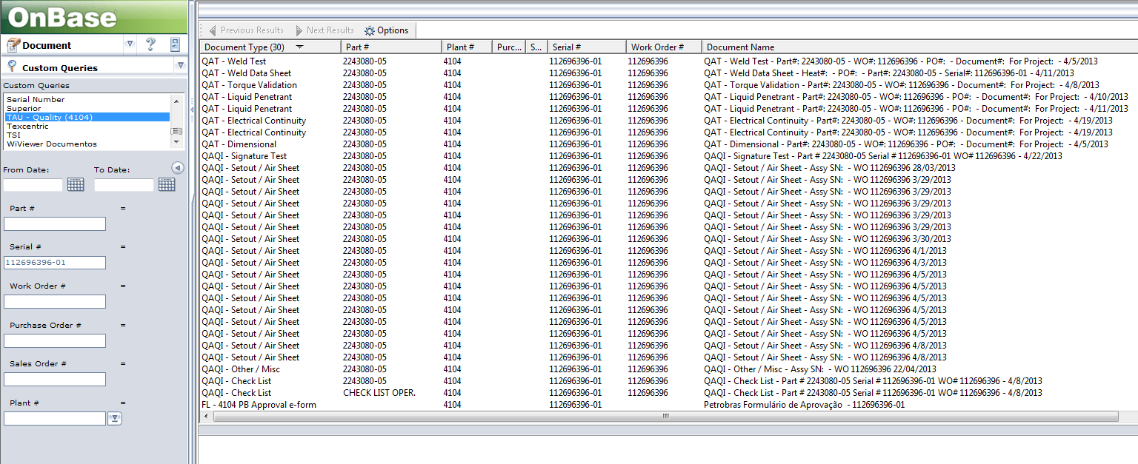

Different document types returned according with ITP file.

To minimize the number of QAI – Setout/Air sheet documents type a 6 sigma project has been started. This will decrease the number of these scanned documents associated with assembly parts and will put a better control on WIP.

## Issue #1 Proposed Solution - OnBase Data Download Program

Below is a proposed application to automate data extraction based on traceability map file maintained by MRB team.

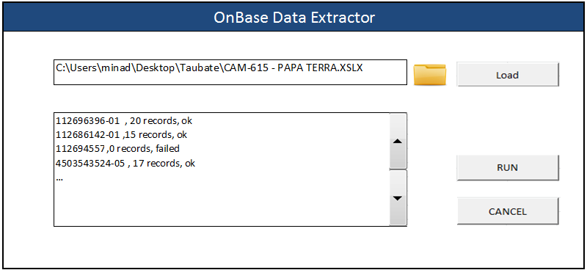

## OnBase Data Download Proposed Results

Two outputs planned for this application:

* A folder structure (similar with tracebility map file).Planned convention name is level + serial number + part description. These folders will be populated with OnBase documents (API function used to get this data).
* A log file containg data extraction results. This file can be used to review results and correct errors.

## Proposed Folder Structure

Home folder (Project Name).

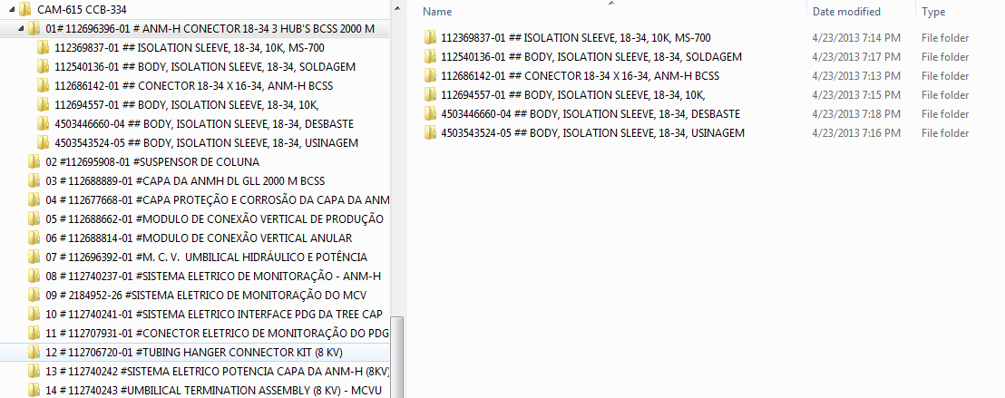

## Data processing log file



Comma separated file. Can be used for download review (as usual there are more than 1000 s/n for project).

## Issue #2 Proposed Solution - Configuration – mapping to keywords

Prerequisite: Project Name keyword to be common for all used documents. Need access to console to check.

Not all documents are index properly. An internal work instruction will be created to fill all the required keywords. Below are 2 documents linked to the same serial number with and without Project name keyword updated.

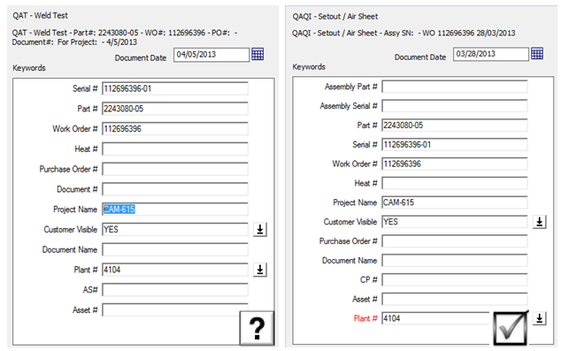

## Query documents for project

There is a need to query OnBase documents related to a specific project. Custom query created for 4104 can be easy changed to accommodate Project Name keyword.

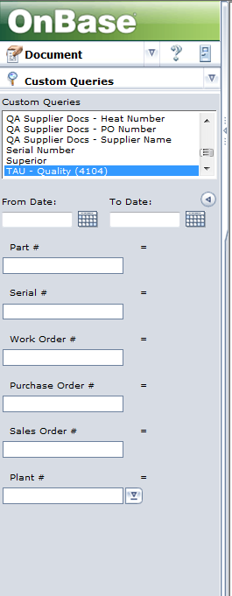

Proposed to add Project Name on Custom Query

## Issue #3 Proposed Solution - Notes for Rejection Report

* Once all required documents are added on serial nubber the approval e-form is started the custoer is notified through NOI on email.

NOI sample:



* Costomer analyze all documents and decide to apporove (all documets) or to reject te proposal creating a rejection note showing rejection reazon, then retun back the NOI file with Rejected status for the sepecific serial number.

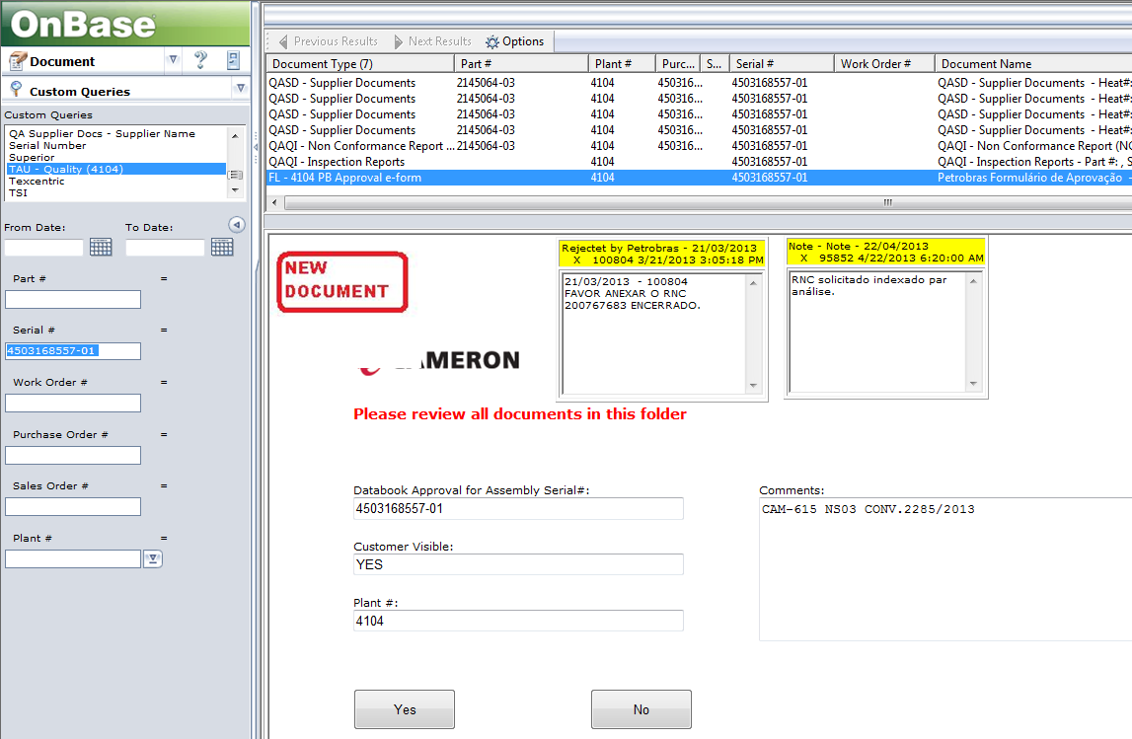

## Notes for Rejection Report Template

For eah serial number all the notes will be extracted. The program should provide a numner of selection criteria (lProject, list or serailnumbers, only s/n with rejection notes, a specific time interval). Report will be published on the existing Microsoft Reporting Services server.

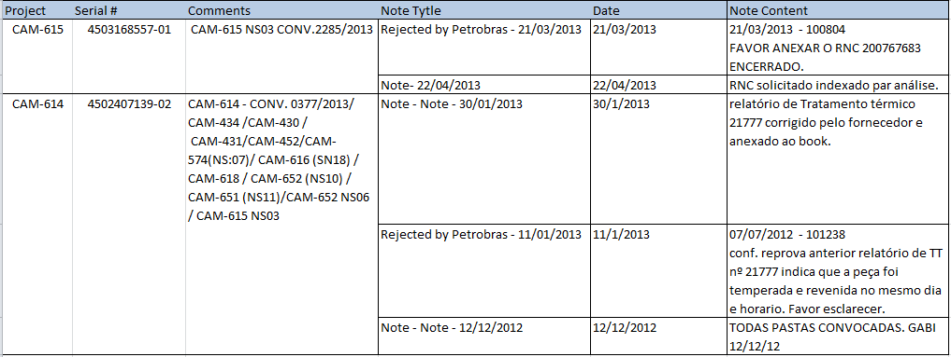

## Issue #4 Proposed Solution - OnBase DIP from FTP

Option 1 (preffered): Build a app which should be executed by vendors when they load certificates. Need vendor acceptance. Will move the indexing work on vendor side for serialization. Cameron will have to reviw documnt for conformance. Data will be imported through OnBase DIP.

Option2: Vendos will continue the existing process and Cameron will need to index documents directly in OnBase to assure serailiazation and data quality.

Both solutions will eliminate the need for print / scan and index with Kofax.

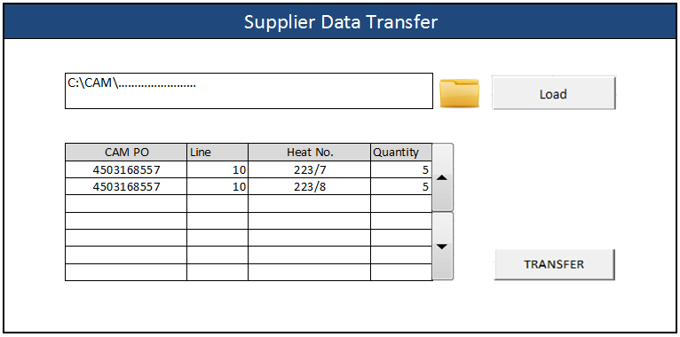

## Issue #5 Proposed Solution - Downgrade approval level